Hellenic Polytheism
Element of Culture
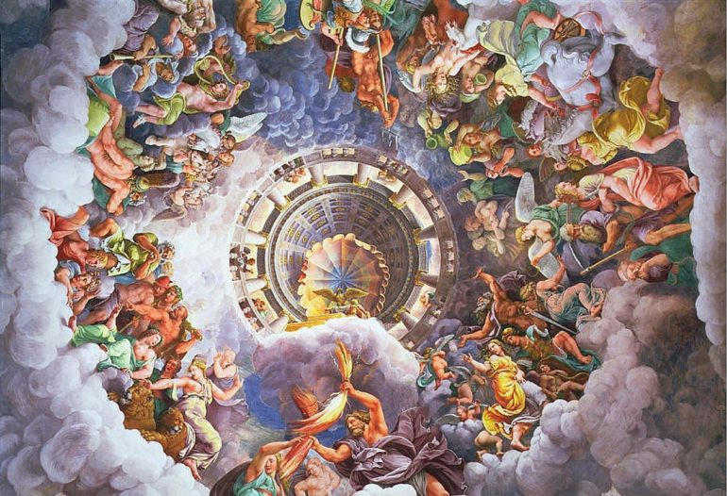
Author- Marsh, Lily-Ann
1.0 Introduction | 1
2.0 Dispersal of Hellenic Polytheism | 2
3.0 Diffusion of Hellenic Polytheism | 3
3.1 Factor One – Role of the Media | 4
3.2 Factor Two – Role of other impacting religions. | 5
4.0 Case Studies | 6
4.1 Case Study One – Embracing Hellenic Polytheism | 6
4.2 Case Study Two – Adapting Hellenic Polytheism | 7
5.0 Implications of the changes in the Nature and Spatial Distribution of Hellenic Polytheism | 8
6.0 Likely future changes in the nature and spatial distribution of Hellenic Polytheism | 9
7.0 Bibliography | 10
Table of
Contents

1.0 Introduction
Introduce the purpose of your report, the element of culture. You may like to define culture and how your chosen element fits as an element. List the areas to be covered in your report. This section could be about a paragraph in length.
The arts and other manifestations of human intellectual achievement regarded collectively.
The ideas, customs, and social behaviour of a particular people or society.
2.0 ORIGIN OF THE HELLENISTIC RELIGION
The original story of the Hellenistic religion revolves around Cronus, Rhea, Zeus, Poseidon and Hades.
Zeus, the youngest of the original deities, God of the sky, bearer of the famed Master Bolt, King of Olympus. His story began when his father, Cronus, destined to be killed by his children, made the decision to swallow them alive. Zeus’ mother, Rhea, deceived Cronus by feeding him a rock and hiding the infant Zeus until he was of age.
As the deity came of age, he freed his two brothers, Hades and Poseidon, from their father’s stomach and worked collectively to defeat their Titan father.
Cronus, like his children, unable to be killed, was imprisoned in the depths of the underworld; this place is Tartarus.
After Cronus’ defeat the three brothers equally divided the three domains between each other. Zeus owned the skies, Poseidon the seas and Hades the underworld. The Gods ascended to the highest point in Greece, this being the tallest hill, Mount Olympus in Athens, which is the court of the Gods. And thus, the age of the Gods began.

2.1 Dispersal of Hellenic Polytheism
During the Peloponnesian war, the Athenians and Spartans fought together against the Persians.
The King of Macedonia, King Phillip II had planned to expand his territories outward in the early 360s B.C, his goal was to conquer Persia. During this time, Greece was weak in its main city and was quite disorganised.
After approximately thirty years of King Phillip’s reign, he was assassinated at his daughter’s wedding and his son, Alexander, took the throne in 336 B.C.
Alexander, more commonly known as Alexander the Great, ruled over Macedonia for thirteen years. Within those years, Alexander built an empire; this empire stretched from Greece to India. Greek ideas and culture expanded across from Eastern Mediterranean to Asia.
With this empire, the Hellenistic Age began.

3.0 diffusion of Hellenic Polytheism
Alexander’s empire was fragile and not destined to last long; so as his death came about his land was divided between his four most trusted Generals.
These dynasties, no longer apart of the Macedonian empire, spread towards the Seleucids of Syria and Persia, the Ptolemies of Egypt and the Antigonids of Greece. Though ranging in many differences, there was one common factor throughout the dynasties: their ‘Greek-ness’ of the disparate parts of the Alexandrian world.
With this expansion, there was trade. Ivory, Gold, Ebony, Pearls, Cotton, Spices and Sugar from India; Furs and Irons from the Far East and Wine from Syria and Chios.
As the expansion and trade continued, stories and myths were passed along by travelers and traders. There were stories of Beasts taking apart ships in the sea, Beasts with multiple heads tearing apart battalions.
3.1 factor one – Role of the Media
The role of the media has helped diffuse Hellenism into modern day society through a broad network or movies and books. Movies being Clash of the Titans (1984 and 2010), Percy Jackson and the sequel to Clash of the Titans: Wrath of the Titans. The books, that are most known in the Hellenism side of religion are the Percy Jackson series and many other series written by the Author Rick Riordan.
Though, the movie industry has had a greater effect on the diffusion of Hellenism. The effect of this diffusion is both negative and positive, as it helped it resurface in the modern world of today. Though, as a Hellenes myself there is a vast majority of negative impacts within its modern day diffusion.
The negative impacts being the fact that the media portrays Hellenism to be a cult-like religion closely related to Paganism. Though this is untrue, movie such as Clash of the Titans, on both occasions, have watered down the myths and the legends and the deities themselves. Movie media has changed roles and dynamics of the religion and culture for fame and more interesting plot line.
An example of this being switching the roles of Zeus and Hades. Though the domains remained the same, Zeus became a fair king, looking after his creations and doing no harm; whereas Hades became a dictator of his domain, cunning, sinister and evil. Plotting to overthrow his brother, and freeing himself from the imprisonment in the underworld.
In the ancient days, Hades was considered the kindest of the three brothers. Due to the fact that Hades rules over the underworld and has to sort through which souls deserve eternal punishment or which deserve eternal blessing; Hades had the biggest moral compass of the Olympians.
The movie media drastically changed the kind and fair deity and portrayed him as the symbol of Death itself. Though, Thanatos, God of Death, was that symbol. Whereas Hades was just the Lord of the Dead.
The unusual fact about this drastic change would be that fact that Religious Historians are puzzled as to where the change occurred. Many historians believe it was the introduction of Catholicism into Greece that changed his role in Hellenism as the Catholics had a similar realm to the Underworld, and the ruler of their under-world was evil.

3.2 factor two – Role of other impacting religions
Other impacting religions are too a facilitating factor of diffusion. Though, this too is more negative that positive.
As quick as Hellenism had begun it had ended. The Romans had adopted the religion, adapting it to their ruler’s beliefs (Julius Caesar) and calling it Greco-Roman culture. Though, this religion was soon dropped when Catholicism and Christianity was introduced into Rome; which had conquered Greece.
Catholicism and Christianity still largely dominate the two countries in the present day, though the Vatican has realised in recent years a small percentage of the populations still follow the Greco-Roman religion and culture. As a result a small, temporary, temple has been opened up in Greece whilst a larger one is being planned out in Athens.

4.0 CASE STUDIES
The Percy Jackson series followed a young demigod, son of Poseidon, who always seems to have a new problem and prophecy each year. Riordan was able to accurately incorporate the Hellenes Religion into modern day society; this is an adaptation to the original Hellenic religion. Some Catholic groups, such as the Vatican have begun to recognise Hellenism as a religion and not just legend and myth based. The church opened a temple in Aristotles Kakogeogiou in Greece.
4.1 Case Study One – ADAPTING Hellenic Polytheism
There are many examples throughout history of cultures and societies that have adapted Hellenistic views and properties. Though, a modern day example would the Percy Jackson series, written by Rick Riordan. Riordan’s novels sold upwards of twenty million copies worldwide; more than 300 fans filled libraries during book signings in the US.
The Percy Jackson series followed a young demigod, son of Poseidon, who always seems to have a new problem and prophecy each year. Riordan was able to accurately incorporate the Hellenes Religion into modern day society.
Though, the adaptation is one of fiction; it fits well into certain aspects of the US city life in NYC.
Riordan’s adaptations to suit his readers and intended audience are how Riordan depicted Medusa as a proprietress of a garden centre in New Jersey, who sells life like statues, another adaptation being Ares, the God of War, who is depicted as a biker in a red muscle shirt who carries around large knives.
Another adaptation involving Medusa, was one that he adapted to suit young readers. Poseidon had dated Medusa and had made out with her in Athena’s temple; which is highly disrespectful. Athena cursed Medusa as punishment. The original story is much darker and more brutal.
The Percy Jackson series and a few other off-shoots of the series have inspired summer camps inspired by Riordan’s works have begun to pop up within the USA.

4.2 Case Study Two – Embracing Hellenic Polytheism
As mentioned earlier in the report, the Vatican have begun to recognised Hellenism as a religion in recent years. The church opened a temple in Aristotles Kakogeogiou in Greece.
The reasoning for the sudden acceptance of the religion was the fact that approximately 2000 Greek citizens followed the religion and around 100 000 were interested in it. As well as groups existing outside of Greece, which had started up in the late 90s.
To truely embrace and accept the Hellenistic religion and culture, there is a Festival held in Athens; this festival is known as Labrys. Which is one of Greece’s largest tourism attractions.

5.0 Changes in the Nature and Spatial Distribution of Hellenic Polytheism
Discuss the implications, such as the advantages and disadvantages associated with the changes in the nature and spatial distribution of the selected element of culture.
You may like to organize this in a table – you should try to use graphic organizers where possible in your report.

Key here is to look at a range of scales and discuss the implications in the changes in the nature and spatial distribution of your element of culture. Eg; on a national scale, as more countries move to democratic models of government, there is increased freedoms.

Area/Question 4
- Investigate and present information about the implications of the changes in the nature and spatial distribution of the element of culture for peoples and places at a range of scales, including the local. (10 marks)

Description | Marks
Provides very detailed, comprehensive and accurate information of the implications, such as the advantages and disadvantages associated with the changes in the nature and spatial distribution of the selected element of culture.  Uses specific examples of peoples and places that have been affected at a range of scales, including the local.  Applies a wide range of appropriate supporting evidence (including quotations, sources, statistics, data, maps, diagrams and/or sketches) and relevant geographical terminology and concepts to enhance the information provided. | 9–10

6.0 Likely future changes in the nature and spatial distribution of Hellenic Polytheism
Discuss the future trends for your element of culture, will it continue to be embraced? Or is it looking like it will evolve and adapt. Perhaps there will be more resistance. Ensure you provide supporting evidence for your predictions.
Examples: Democracy is continuing to diffuse to traditionally closed and tyrannical regions in the middle east, communities in Iraq are fighting for their freedoms.

Area/Question 5
- Investigate and present information/predictions about the likely future changes in the nature and spatial distribution of the element of culture.

(6 marks)
Description | Marks
Presents generalized information and predictions about the future diffusion, adoption and/or adaptation of the selected element of culture, based on available evidence. Provides maps and/or diagrams to support the suggested trend. | 5–6

7.0 Bibliography
Sources must be in the correct format – refer to the Curtin Referencing guide in the LIBRARY SECTION and ordered in Alphabetical Order by Author.

Provide a bibliography which follows the school’s referencing protocol

Description | Marks
Bibliography includes a comprehensive list of primary sources (e.g. interviews, questionnaires, students’ own experiences, and field observations) and/or secondary sources (e.g. online maps, websites, spatial software applications, print resources and visual media) which correctly follow the referencing technique approved by the school | 5-6

The Percy Jackson Problem | The New Yorker

OVERALL MARKING KEY FOR THE REPORT
Description | Marks
Findings (Report) include a comprehensive range of accurate supporting evidence (including quotations, sources, statistics, data, maps, sketches and/or diagrams) to develop and enhance explanations and information, including reference to supporting evidence, such as data, statistics and examples. Uses appropriate headings and sub-headings to structure report and uses all key research areas from Geographical Knowledge and Understanding.  Applies relevant geographical terminology and concepts to develop concise explanations and information.  Uses a correctly formatted report structure throughout, including cover page, contents page, introduction, body (structured headings and sub-headings) and conclusion. May include an appendix  Selects and correctly applies a wide range of appropriate supporting evidence, including examples, quotations, sources, statistics, data, maps and/or sketches, when developing findings. | 8–10

